Lahore Garrison University
DHA Phase 6 Lahore


Student Name | Saim Ali
Student Roll No | Fa-2023/BSCS/162
Section | D,
Subject | Web Technology
Instructor Name | Mr. Muhammad Yousaf

Lab Task No. 10
Advanced JavaScript — Objects, Arrays, JSON, ES6
Objectives:
Use ES6 features and fetch/display JSON. Parse and manipulate arrays/objects.
Tools/Tech:
- VS Code
- Fetch API or sample JSON file
- modern browser

Tasks/Steps:
1. Create a small app that fetches JSON (local or public API) and renders items (e.g., product list).
2. Use ES6 constructs: let/const, arrow functions, template literals, destructuring.
3. Implement filtering/sorting of the fetched data.
Deliverables:
App with fetch functionality and code demonstrating ES6 features.
Html Code
<!DOCTYPE html>
<html lang="en">
<head>
<meta charset="UTF-8">
<meta name="viewport" content="width=device-width, initial-scale=1.0">
<title>Lab 10 - Advanced JavaScript</title>
<link rel="stylesheet" href="style.css">
</head>
<body>
<h1>Product Store (JSON + ES6)</h1>
<div class="controls">
<button onclick="sortPriceLow()">Sort: Low → High</button>
<button onclick="sortPriceHigh()">Sort: High → Low</button>
<button onclick="filterCategory('electronics')">Electronics</button>
<button onclick="filterCategory('jewelery')">Jewelery</button>
<button onclick="renderProducts(allProducts)">Reset</button>
</div>
<div id="product-list" class="product-list"></div>
<script src="script.js"></script>
</body>
</html>
CSS Code
body {
font-family: Arial, sans-serif;
background: #f4f4f4;
margin: 0;
padding: 20px;
}
h1 {
text-align: center;
margin-bottom: 20px;
}
.controls {
text-align: center;
margin-bottom: 20px;
}

.controls button {
padding: 10px 15px;
margin: 5px;
border: none;
background: #007bff;
color: white;
cursor: pointer;
border-radius: 5px;
}
.controls button:hover {
background: #0056b3;
}
.product-list {
display: grid;
grid-template-columns: repeat(auto-fit, minmax(250px, 1fr));
gap: 15px;
}
.card {
background: white;
padding: 15px;
border-radius: 8px;
text-align: center;
box-shadow: 0 2px 6px rgba(0,0,0,0.1);
}

.card img {
width: 100px;
height: 100px;
object-fit: contain;
}
.card h3 {
font-size: 16px;
margin: 10px 0;
}
.card p {
margin: 5px 0;
color: #555;
}

JS Code
// API URL
const apiURL = "https://fakestoreapi.com/products";
// Fetch Products (ES6 + async/await)
const fetchProducts = async () => {
const response = await fetch(apiURL);
const data = await response.json();
window.allProducts = data; // save globally
renderProducts(data);
};

fetchProducts();

// Render Products (Arrow Function + Template Literals + Destructuring)
const renderProducts = (products) => {
const container = document.getElementById("product-list");
container.innerHTML = "";

products.forEach(({ title, price, category, image }) => {
container.innerHTML += `
<div class="card">
<img src="${image}" alt="${title}">
<h3>${title}</h3>
<p>Category: ${category}</p>
<p>Price: $${price}</p>
</div>
`;
});
};

// Sorting Functions
const sortPriceLow = () => {
const sorted = [...allProducts].sort((a, b) => a.price - b.price);
renderProducts(sorted);
};

const sortPriceHigh = () => {
const sorted = [...allProducts].sort((a, b) => b.price - a.price);
renderProducts(sorted);
};

// Filter by Category
const filterCategory = (category) => {
const filtered = allProducts.filter(product => product.category === category);
renderProducts(filtered);
};
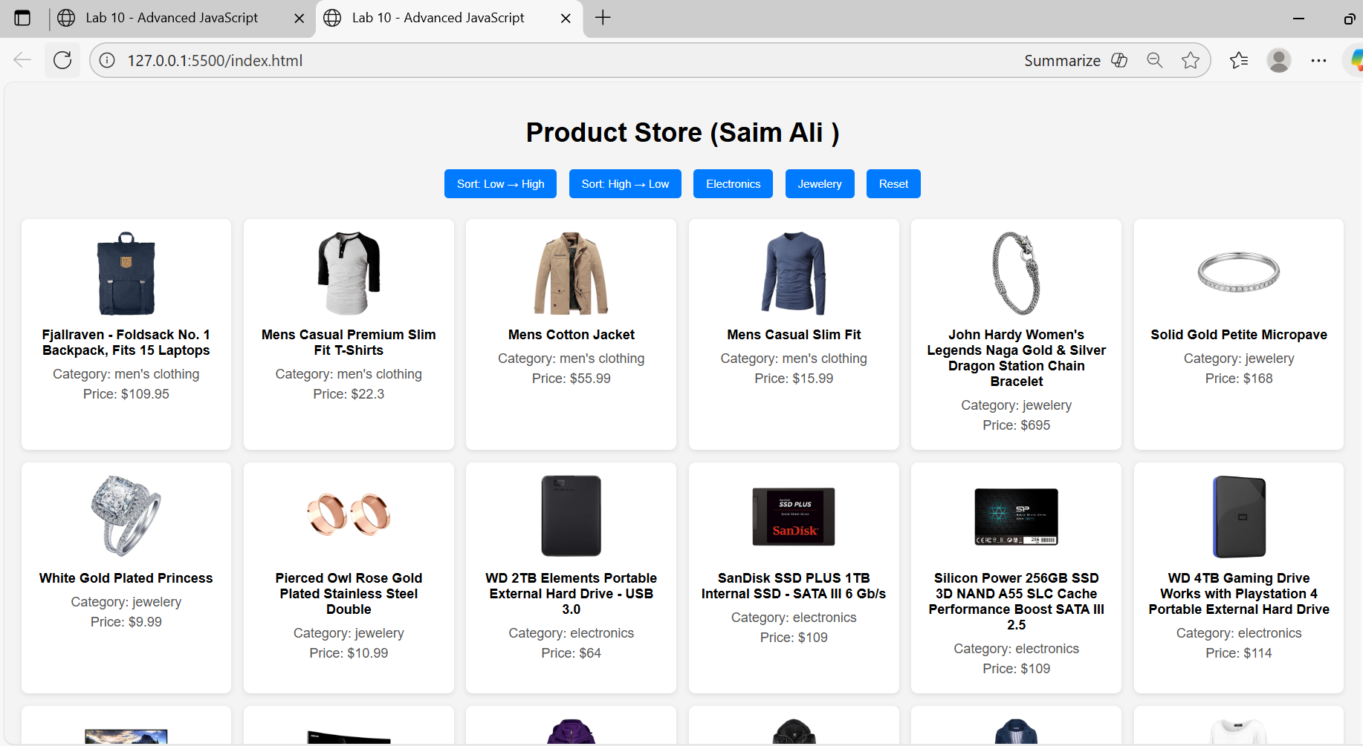

CONCLUSION:
This lab helped me understand JavaScript basics by building a fully functional calculator using DOM manipulation and event handling. I learned how to debug using the console and apply breakpoints to trace logic flow. Overall, the activity improved my confidence in writing interactive and dynamic web applications.
RUBRICS:
Performance |  |  | Lab Report
Description | Total Marks | Marks Obtained | Description | Total Marks | Marks  Obtained
Ability to Conduct practical | 5 |  | Structure | 5
Data Analysis & Interpretation | 5 |  | Efficiency | 5
Total Marks obtained |  |  | Total Marks Obtained

Instructor Signature

